

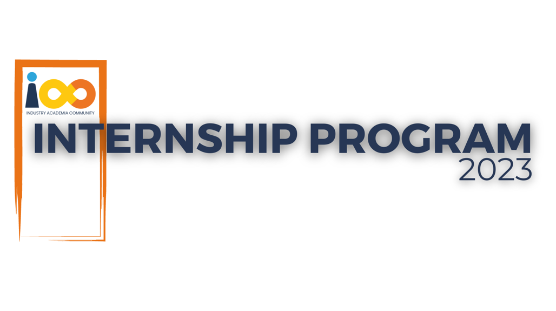

PROJECT REPORT

Data Analytics   
  
 Data Analytics for Student Insights

|  |  |  |  |
| --- | --- | --- | --- |
| **Created By:** | Vaibhavi Kapse | **Approved By:** | Harshada Topale |
| **Created On:** | 12-06-2024 | **Approved On:** |  |

Page left blank intentionally

**INDEX**

**1** **PROJECT DETAILS** 2

**2** **SUMMARY** 2

**3** **INTRODUCTION** 2

3.1 Background 2

3.2 Stakeholders 2

3.3 Objectives 2

**4** **METHODOLOGY** 2

4.1 Considerations & Assumption 3

4.2 Approach 3

4.3 Activities 3

**5** **TARGETTED V/S ACHIEVED OUTPUT** 3

**6** **CONCLUSION** 3

**7** **APPENDICES** 4

7.1 Appendix A – Title 4

**General Instructions for using the Live Project Report Template**

* This template and the subsequent document created using this template is a confidential document and is the intellectual property of Cloud Counselage Pvt. Ltd. Circulating it outside of the organisation without the consent of Cloud Counselage Pvt. Ltd. is the breach of company policies and will lead to legal actions
* This template is a guideline document to communicate the implementation of design ideas and the results of the work to the stakeholders.
* The **text between inequality (< >) is to be replaced** by relevant text
* Please **remove the yellow highlight on the Text** between the inequality (< >). This is done to help you notice the text to be changed/replaced
* The text in *italics* highlighted in grey is just for reference and should be removed after adding the relevant text

# **PROJECT DETAILS**

|  |  |  |  |
| --- | --- | --- | --- |
| **Project Name** | Data Analytics for Student Insights | | |
| **Project Sponsor** | Tushar Topale | | |
| **Project Manager** | Harshada Topale | | |
| **Start Date** | 12-06-2024 | **Completion Date** | 09-07-2024 |

# **SUMMARY**

*<Explain what the project was expected to deliver, why the project was needed and what the long-term benefits have been or will be. Even though a summary is placed at the beginning of a project report, you can only write it once your entire report is complete.>*

This project aimed to deliver comprehensive insights into the relationships between students' economic backgrounds, academic performance, competence, and expected salary. It was needed to provide actionable data to enhance decision-making for educational institutions and career guidance programs. The long-term benefits include improved student support systems, better career guidance, and data-driven educational policies.

# **INTRODUCTION**

## Background

*<Take this section from the problem statement & the discussion points from requirement elicitation meeting>*

Millions of students apply for internships/jobs every year, and their resumes play an important role in making the first impression. Recruiters spend only 2-3 minutes reviewing a resume, with more than 70% of resumes getting rejected during the initial screening. Thus, it’s important to pay attention to details and spend quality time preparing a resume to pass this initial screening. This project focuses on analyzing the relationship between students' economic background, academic performance, competence, and expected salary.

## Stakeholders

*<Take this section from the problem statement & the discussion points from requirement elicitation meeting>*

• **Students**: Beneficiaries of insights for better career and academic decisions.

• **Educational Institutions**: Utilize the findings for improving student support systems.

• **Career Counselors**: Gain data-driven insights to guide students effectively.

• **Employers**: Understand the potential of candidates based on comprehensive data.

## Objectives

*<Reference the objectives in the* ***Project Charter*** *and describe what has been achieved. If there were any changes to the project objectives since the* ***Project Charter*** *was approved/submission they should be documented here.>*

The primary objective was to analyze student data to uncover significant insights regarding economic background, academic performance, and expected salary. Specific objectives included:

* Automating the data collection process.
* Analyzing data to identify trends and correlations.
* Visualizing data in an easily interpretable format.
* Generating comprehensive reports.

# **METHODOLOGY**

These conventions are all about the positions of line breaks, how many characters should go on a line, and everything in between.

## Considerations & Assumption

*<Mention any constraints, challenges and reasons for making the assumptions you made for delivering this project that formed to basis for working on this project>*

• Data privacy and security were maintained throughout the project.

• Assumed access to accurate and comprehensive student data.

•Assumed the availability of required software tools and active participation from stakeholders.

## Approach

*<Mention the structured approach you adopted to solve the problem and why. Keep it conceptual>*

A structured approach was adopted, which included:

* Data Collection: Automated scraping of student data using BeautifulSoup and Selenium.
* Data Analysis: Using Python and R for data cleaning and analysis.
* Data Visualization: Creating interactive dashboards with Power BI and Tableau.
* Reporting: Generating detailed reports based on the analyzed data.

## Activities

*<Mention the activities you performed to deliver the project. E.g. requirement gathering, planning, etc.>*

• Requirement Gathering: Identified and documented project requirements.

• Planning: Developed a detailed project plan.

• Data Collection: Scraped and collected student data.

• Data Cleaning: Processed and cleaned the collected data for analysis.

• Data Analysis: Performed statistical and qualitative analysis.

• Visualization: Created dashboards and visual reports.

• Reporting: Compiled findings into comprehensive reports.

# **TARGETTED V/S ACHIEVED OUTPUT**

*<Mention the targeted output in the project plan and against it what you have been able to achieve. Also mention the reason of deviation. Please remember the deviations will not impact the evaluation and the results of your internship. This sections will help you to analyse the results and understand the cause for deviation that will be lessons learnt for you and would help you to perform better in the next project>*

The targeted output was to deliver actionable insights from the student data analysis. We successfully collected and analyzed the data, created visual dashboards, and generated reports. Any deviations from the original plan were primarily due to minor delays in data collection and processing, which were managed effectively without impacting the final delivery.

# **CONCLUSION**

*<Mention the how it will prove to be useful for the stakeholders and what can be the future scope>*

This project has provided valuable insights into the relationships between various student factors, proving useful for educational institutions, career counselors, and employers. Future scope includes expanding the dataset to include more variables and applying the insights to develop predictive models for student success.

# **APPENDICES**

## Appendix A – Data Attributes

* **Vaibhavi Kapse**
* **2**
* [Kapsevaibhavi1224@gmail.com](mailto:Kapsevaibhavi1224@gmail.com)
* **New Horizon Institute of Technology And Management**
* **Year of Graduation**: 2025
* **City**: Thane
* **GPA**: 8
* **Experience with Python**: 24
* **Family Income**: 2,00,000
* **Expected Salary**: 8,00,000
* **Leadership Skills**: yes